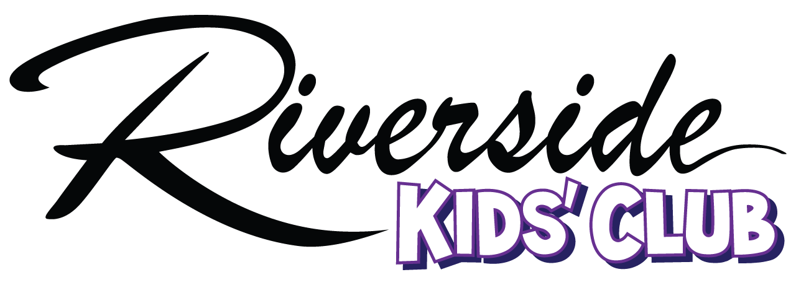

Rules and Regulations
…helping active parents raise healthy, active kids.

- Children ages newborn through twelve years of age are welcome to play in Kids’ Club.
- Kids’ Club is a “Drop in Care Center,” according to Washington State Regulation.
(http.//nccic.acf.hhs.gov/poptopics/dropin.html). Because of this designation:
- The parent who is signed the child in must be on the RHC premises at all times during the Kids’ Club visit.
- Children may be in the Kids’ Club no more than three hours per day. If a parent goes over the limit, he/she will be paged and asked to get his/her child.
- All parents must be available and respond promptly. If a parent does not respond within a reasonable time frame, the parent will be approached my an RHC employee.
- When signing in the child, the parent accepts all responsibility for the safety of the child and agrees RHC Kids’ Club and its attendants will be held harmless and free of any liability for any possible accident, injury and/or illness incurred while visiting the RHC Kid’s Club.
- Unless notified, only the person signing the child in will be able to remove the child from Kids’ Club. Any person without a clear picture in the system will be asked to show identification.
- Bags, bottles, diapers and coats should be labeled with child’s name.
- To maintain a healthy environment in Kids’ Club please be considerate to others and refrain from bringing any children that are ill. If a child comes to Kids’ Club exhibiting symptoms (such as runny nose with color or red bumps) the parent will be called and asked not to return until the child is no longer ill.
- Kids’ Club is a NUT-FREE ZONE. If a child brings a snack that contains nuts or was processed in a facility that handles nuts, the snack will not be given to the child. The snack will be removed from the Kids’ Club.
- There is not a specific lunch time or nap time. If parents wish for their child to have a snack, they may bring one or purchase snacks provided in the Kids’ Club. Snacks should be age-appropriate. For toddlers we ask that finger foods be used rather than bottled baby food. Occasional snacks may be provided by RHC for special events.
- Snacks are available for purchase in Kids’ Club. Please ask an attendanat for a list of available foods. All snacks must be pre-paid or paid for when they are taken. See attendant for pre-pay details.
- Please see current hand out for Kids’ Club hours.
- Discipline: A child may be asked to take a leave of absence, a week to a month, etc. if the child is routinely harmful to other children. We employ age-approprate time outs if a child is not adhering to the rules in Kids’ Club. These incidents are reported to the parent at the end of their stay. Please communicate to the attendants any concerns you may have.
- Riverside Health Club Kids’ Club may suspend or terminate memberships of any member who:
  - Fails to pay an initiation fee installment, monthly dues payments or additional charges (snacks) promptly when due.
  - Breaches any provision of their Membership Agreement or the Rules and Regulations of Riverside Health Club and Kids’ Club Rules and Regulations.
  - Harrasses or disrupts normal club activites or any Member. Such judgement is at the sole discretion of club management, which shall be reasonably applied. Upon suspension, the Member shall pay all current fees and charges, such and outstanding snacks, as agreed.

